Runtime images（制做独立运行模块）
If you want to create a runtime image of your JavaFX 12 project follow these instructions.
Download an appropriate JavaFX runtime and JavaFX jmods for your operating system and unzip them to a desired location.
Add these environment variables pointing to the lib directory of the runtime and to the jmods directory:
- Linux/Mac
export PATH_TO_FX=path/to/javafx-sdk-12.0.1/lib
export PATH_TO_FX_MODS=path/to/javafx-jmods-12.0.1
- Windows
set PATH_TO_FX="path\to\javafx-sdk-12.0.1\lib"
set PATH_TO_FX_MODS="path\to\javafx-jmods-12.0.1"

Command Line
You can run or create a runtime image of your JavaFX 12 project from command line. A simple example can be found in this project.
The application has a single class HelloFX.java with its module-info file that defines the hellofx module. Compile it either using the JavaFX SDK:
- Linux/Mac
javac --module-path $PATH_TO_FX -d mods/hellofx $(find src/ -name "*.java")
- Windows
dir /s /b src\*.java > sources.txt & javac --module-path %PATH_TO_FX% -d mods/hellofx @sources.txt & del sources.txt

or using the JavaFX jmods:
- Linux/Mac
javac --module-path $PATH_TO_FX_MODS -d mods/hellofx $(find src/ -name "*.java")
- Windows
dir /s /b src\*.java > sources.txt & javac --module-path %PATH_TO_FX_MODS% -d mods/hellofx @sources.txt & del sources.txt

Note: Note that the output is placed under mods/hellofx for convenience, but it could use any other name.
To run the modular application with the java command you need the JavaFX SDK modules and your module added to the module path:
- Linux/Mac
java --module-path $PATH_TO_FX:mods -m hellofx/hellofx.HelloFX
- Windows
java --module-path "%PATH_TO_FX%;mods" -m hellofx/hellofx.HelloFX

jlink
With a modular project, jlink can be used to create a custom runtime image using the JavaFX jmods:
- Linux/Mac
$JAVA_HOME/bin/jlink --module-path $PATH_TO_FX_MODS:mods --add-modules hellofx --output hellofx
- Windows
jlink --module-path "%PATH_TO_FX_MODS%;mods" --add-modules hellofx --output hellofx

And after the image is built, you can run it:
- Linux/Mac
hellofx/bin/java -m hellofx/hellofx.HelloFX
- Windows
hellofx\bin\java -m hellofx/hellofx.HelloFX
Note: This custom JRE is platform-specific.

Maven
You can run or create a runtime of your JavaFX 12 Maven project. A simple example can be found in this project.
The application has a main class MainApp.java with its module-info file that defines the hellofx module. It also uses FXML, and requires the javafx.fxml dependency added to the pom.xml.
It can be compiled and run on command line with javac, but using Maven we can simply do:
mvn clean javafx:run
To create a custom runtime, using the JavaFX Maven plugin, you can do:
mvn clean javafx:jlink
Note the plugin allows the usual options as the jlink command, as well as creating a launcher or a zip with the custom image.
And after the image is built, you can run it from command line:
- Linux/Mac
target/hellofx/bin/launcher
- Windows
target\hellofx\bin\launcher

Gradle
You can run or create a runtime of your JavaFX 12 Gradle project. A simple example can be found in this project.
The application has a main class HelloFX.java with its module-info file that defines the hellofx module, and the required build.gradle file.
It can be compiled and run on command line with javac, but using Gradle we can simply do:
- Linux/Mac
./gradlew run
- Windows
gradlew run

To create a custom runtime the referred steps can be used to generate a gradle task. Alternatively, there is a plugin that does it for us: the org.beryx.jlink. It can be combined with the JavaFX Gradle plugin:
plugins {
id 'application'
id 'org.openjfx.javafxplugin' version '0.0.7'
id 'org.beryx.jlink' version '2.10.2'
}

javafx {
version = "12.0.1"
modules = [ 'javafx.controls' ]
}

jlink {
launcher {
name = 'hellofx'
}
}
to generate and run the custom image:
- Linux/Mac
./gradlew jlink
build/image/bin/hellofx
- Windows
gradlew jlink
build\image\bin\hellofx

Custom JDK+JavaFX image
You can use jlink to create a runtime image that includes some or all the JavaFX modules, without being attached to a given project.
With this image you will be able to run JavaFX modular or non-modular projects, use it as a new JRE from your IDE to create regular JavaFX projects, or even use its jlink command to create a new custom image for your project.
For instance, you can create an image that contains the java.se module and the JavaFX modules, by running:
- Linux/Mac
export PATH_TO_FX_MODS=path/to/javafx-jmods-12.0.1
$JAVA_HOME/bin/jlink --module-path $PATH_TO_FX_MODS --add-modules java.se,javafx.fxml,javafx.web,javafx.media,javafx.swing --bind-services --output /path/to/jdkfx-12.0.1.jdk
- Windows
set PATH_TO_FX_MODS="path\to\javafx-jmods-12.0.1"
%JAVA_HOME%\bin\jlink --module-path %PATH_TO_FX_MODS% --add-modules java.se,javafx.fxml,javafx.web,javafx.media,javafx.swing --bind-services --output \path\to\jdkfx-12.0.1

Use custom image
With this custom image, you can set a new JAVA_HOME:
- Linux/Mac
export JAVA_HOME=/path/to/jdkfx-12.0.1.jdk
- Windows
set JAVA_HOME="path\to\jdkfx-12.0.1"

Since the JavaFX modules are already part of the runtime, now you can run the HelloFX sample without the need of adding PATH_TO_FX anymore, like:
- Linux/Mac
javac -d mods/hellofx $(find src/ -name "*.java")
java --module-path mods -m hellofx/hellofx.HelloFX
- Windows
dir /s /b src\*.java > sources.txt & javac -d mods/hellofx @sources.txt & del sources.txt
java --module-path mods -m hellofx/hellofx.HelloFX

Or add the image to your IDE:

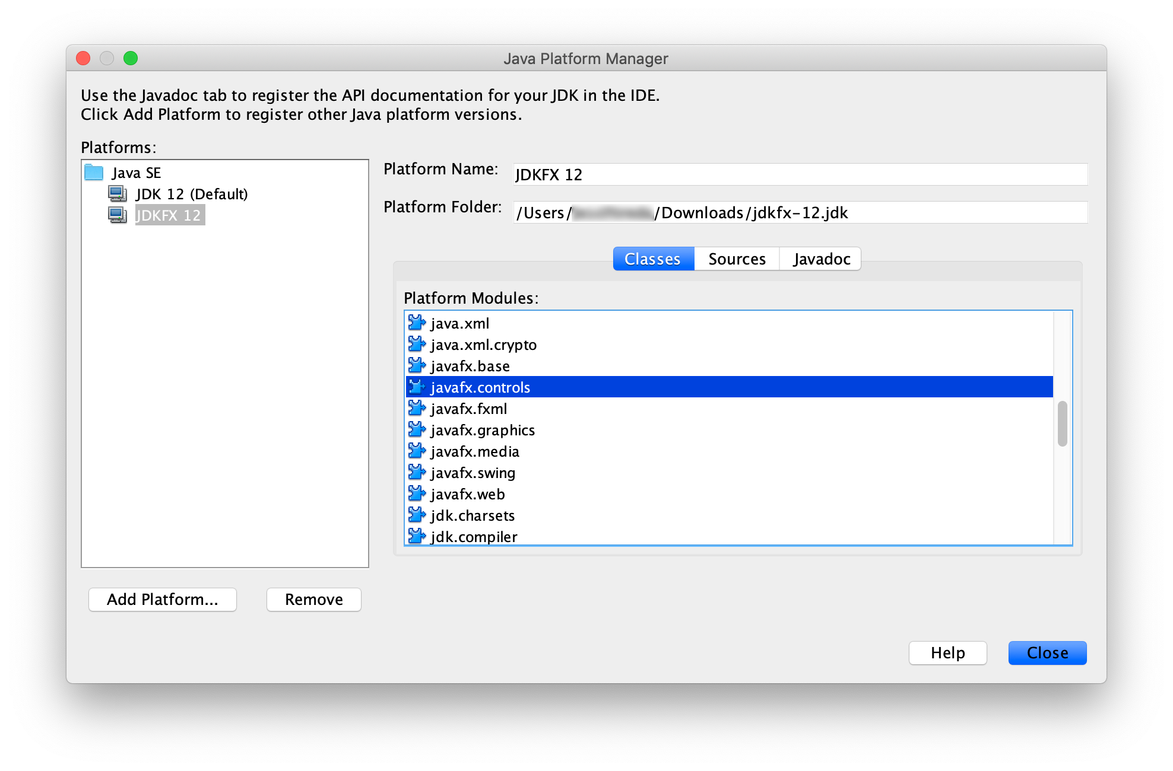
And start creating Java projects with JavaFX classes.
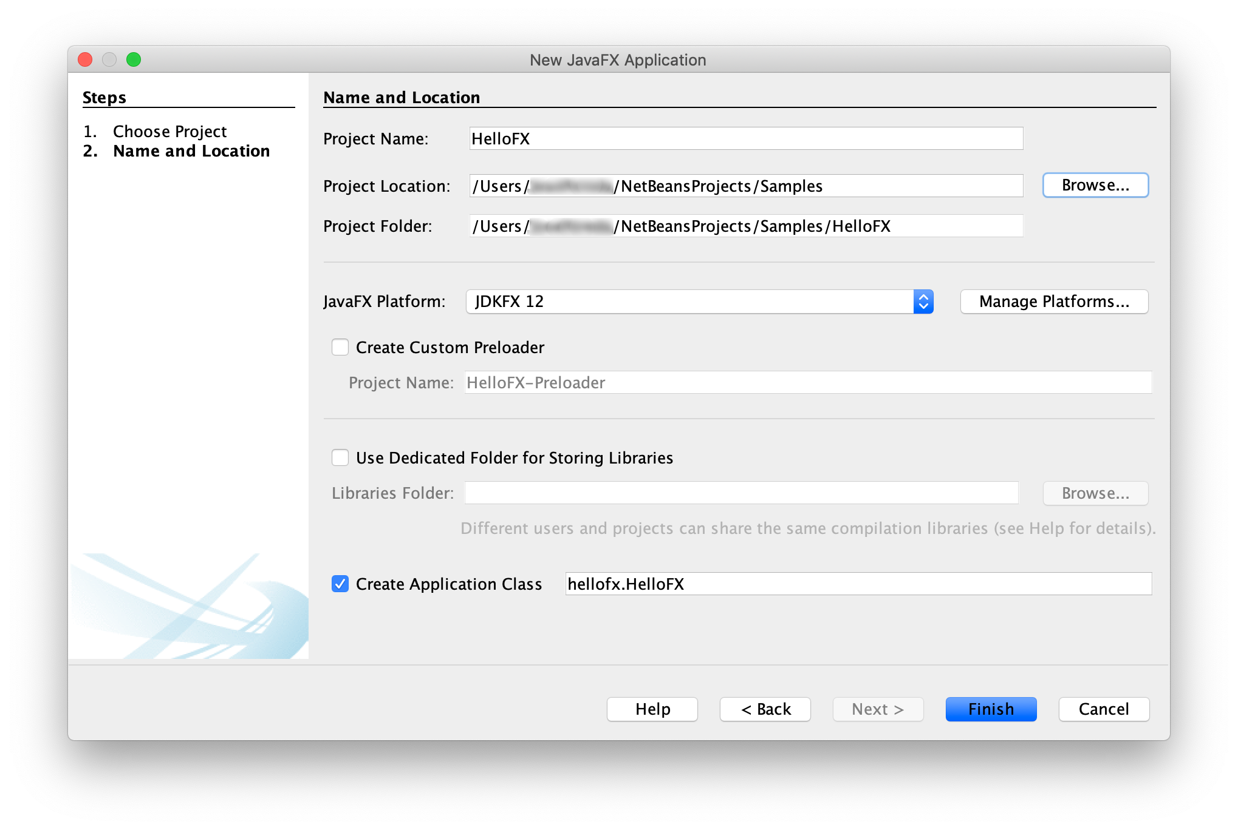
And run them without any additional option:
Note: This custom JRE is platform-specific and it is not intended for distribution, and if there is a new JDK or a new JavaFX SDK, it has to be created all over again. However, its jlink tool can be used to create a custom image with the project that can be distributed. And the (soon to be released) jpackage tool can be used for distributing installers with the jlinked project.

Non-modular application
Since Java 9, applications should be modular, and distributed with tools like jlink. However, if you have a non-modular JavaFX 12 project or you can't use jlink because you have non-modular dependencies where the automatic module naming convention doesn't apply, you can still do a fat jar.
As explained here, in order to create a runnable jar with all the required JavaFX dependencies, you will need to use a launcher class that doesn't extend from Application.

Maven
If you develop your JavaFX applications using Maven, you don't have to download the JavaFX SDK. Just specify the modules and the versions you want in the pom.xml file, and the build system will download the required modules, including the native libraries for your platform.
A simple Maven example can be found in this project. The pom.xml file shows how to create a runnable fat jar for this hellofx project with the Maven shade plugin.
Run the plugin to create the fat jar:
mvn compile package
Run the application using:
- Linux/Mac
java -jar shade/hellofx.jar
- Windows
java -jar shade\hellofx.jar

Cross-platform jar
You can create a cross-platform fat jar by adding the dependencies from the three platforms that require native libraries to your pom file, in this sample only the ones from javafx.graphics:
<dependencies>
...
<dependency>
<groupId>org.openjfx</groupId>
<artifactId>javafx-graphics</artifactId>
<version>12.0.1</version>
<classifier>win</classifier>
</dependency>
<dependency>
<groupId>org.openjfx</groupId>
<artifactId>javafx-graphics</artifactId>
<version>12.0.1</version>
<classifier>linux</classifier>
</dependency>
<dependency>
<groupId>org.openjfx</groupId>
<artifactId>javafx-graphics</artifactId>
<version>12.0.1</version>
<classifier>mac</classifier>
</dependency>
</dependencies>

Gradle
If you develop your JavaFX applications using Gradle, you don't have to download the JavaFX SDK. Just specify the modules and the versions you want in the build.gradle file, and the build system will download the required modules, including the native libraries for your platform. However, for Gradle we need to find and specify the platform/OS as classifier.
A simple Gradle example can be found in this project. In order to create a runnable fat jar for this project with Gradle, modify the jar task in the build file to include the launcher class:
mainClassName = 'hellofx.HelloFX'
jar {
manifest {
attributes 'Main-Class': 'hellofx.Launcher'
}
from {
configurations.runtimeClasspath.collect { it.isDirectory() ? it : zipTree(it) }
}
}
Now run the task to create the fat jar and run it:
- Linux/Mac
./gradlew jar
java -jar build/libs/hellofx.jar
- Windows
gradlew.bat jar
java -jar build\libs\hellofx.jar

Cross-platform jar
You can create a cross-platform fat jar by adding the dependencies from the three platforms that require native libraries to the build file, in this sample only the ones from javafx.graphics:
runtimeOnly "org.openjfx:javafx-graphics:$javafx.version:win"
runtimeOnly "org.openjfx:javafx-graphics:$javafx.version:linux"
runtimeOnly "org.openjfx:javafx-graphics:$javafx.version:mac"
Now run the jar task again to create the cross-platform fat jar.

Command Line
Finally, you can also create a runnable fat jar for your JavaFX 12 project on command line.
Warning: This is a discouraged tedious error-prone manual process that should be avoided by using the Maven's shade plugin or the Gradle's jar task, in case jlink is not applicable.
An example can be found in this project. Download the appropriate JavaFX SDK for your operating system and unzip it to a desired location.
Add an environment variable pointing to the lib directory of the runtime:
- Linux/Mac
export PATH_TO_FX=/path/to/javafx-sdk-12.0.1/lib
- Windows
set PATH_TO_FX="path\to\javafx-sdk-12.0.1\lib"

Compile the project:
- Linux/Mac
javac --module-path $PATH_TO_FX --add-modules=javafx.controls -d out $(find src/main/java -name "*.java")
- Windows
dir /s /b src\main\java\*.java > sources.txt & javac --module-path %PATH_TO_FX% --add-modules=javafx.controls -d out @sources.txt & del sources.txt

And create the fat jar, adding the JavaFX required jars and the platform-specific native libraries. For the hellofxproject:
- Linux/Mac
find $PATH_TO_FX/{javafx.base.jar,javafx.graphics.jar,javafx.controls.jar} -exec unzip -nq {} -d out \;
#uncomment for Linux:
#cp $PATH_TO_FX/{libprism*.so,libjavafx*.so,libglass*.so,libdecora_sse.so} out
#uncomment for Mac:
#cp $PATH_TO_FX/{libprism*.dylib,libjavafx*.dylib,libglass.dylib,libdecora_sse.dylib} out
rm out/META-INF/MANIFEST.MF out/module-info.class
mkdir libs
jar --create --file=libs/hellofx.jar --main-class=hellofx.Launcher -C out .
- Windows
cd out & jar xf "%PATH_TO_FX%\javafx.base.jar" & jar xf "%PATH_TO_FX%\javafx.graphics.jar" & jar xf "%PATH_TO_FX%\javafx.controls.jar" & cd ..
copy "%PATH_TO_FX%\..\bin\prism*.dll" out & copy "%PATH_TO_FX%\..\bin\javafx*.dll" out & copy "%PATH_TO_FX%\..\bin\glass.dll" out && copy "%PATH_TO_FX%\..\bin\decora_sse.dll" out
del out\META-INF\MANIFEST.MF & del out\module-info.class
mkdir libs
jar --create --file=libs/hellofx.jar --main-class=hellofx.Launcher -C out .

And after the jar is built, you can run it:
- Linux/Mac
java -jar libs/hellofx.jar
- Windows
java -jar libs\hellofx.jar

Note: This JRE is platform-specific. However it can be easily a multi-platform jar if the different native libraries from each platform were included. This requires downloading the JavaFX SDKs for all the platforms, extracting all the necessary jars (for instance, javafx.graphics is different for each platform), and copying all the native libraries as shown above. As it was mentioned above, this process shouldn't be done manually.

如果你想制做独立运行的JavaFX模块程序，请参见下面命令：
下载与你操作系统适配的JavaFX runtime 和JavaFX jmods 文件，然后解压到所需的目录。
把环境变量PATH_TO_FX和PATH_TO_FX_MODS分别指向JavaFX runtime和JavaFX jmods库文件所在的目录。
- Linux/Mac
export PATH_TO_FX=path/to/javafx-sdk-12.0.1/lib
export PATH_TO_FX_MODS=path/to/javafx-jmods-12.0.1
- Windows
set PATH_TO_FX="path\to\javafx-sdk-12.0.1\lib"
set PATH_TO_FX_MODS="path\to\javafx-jmods-12.0.1"

Command Line（命令行）
你可以通过命令行方式来生成独立运行的JavaFX模块程序。可以参见project这个简单的例子。
这个程序只有一个HelloFX.java文件，它的模块描述文件module-info定义了hellofx模块。
使用JavaFX SDK编译这个项目的命令如下:
- Linux/Mac
javac --module-path $PATH_TO_FX -d mods/hellofx $(find src/ -name "*.java")
- Windows
dir /s /b src\*.java > sources.txt & javac --module-path %PATH_TO_FX% -d mods/hellofx @sources.txt & del sources.txt

使用JavaFX jmods编译这个项目的命令如下:
- Linux/Mac
javac --module-path $PATH_TO_FX_MODS -d mods/hellofx $(find src/ -name "*.java")
- Windows
dir /s /b src\*.java > sources.txt & javac --module-path %PATH_TO_FX_MODS% -d mods/hellofx @sources.txt & del sources.txt

注意： 我们这里模块名称是hellofx放在mods目录下，你也可以取其它名称。
通过java命令来运行模块化的程序，在命令中要把你生成的模块所在的路径和JavaFX SDK库文件所在路径加到“--module-path”中：
- Linux/Mac
java --module-path $PATH_TO_FX:mods -m hellofx/hellofx.HelloFX
- Windows
java --module-path "%PATH_TO_FX%;mods" -m hellofx/hellofx.HelloFX

jlink
可用jlink命令用来创建独立运行的JavaFX模块化程序：
- Linux/Mac
$JAVA_HOME/bin/jlink --module-path $PATH_TO_FX_MODS:mods --add-modules hellofx --output hellofx
- Windows
jlink --module-path "%PATH_TO_FX_MODS%;mods" --add-modules hellofx --output hellofx

通过上述命令创建了独立运行的JavaFX模块化程序后，你可以通过下面的命令来运行它：
- Linux/Mac
hellofx/bin/java -m hellofx/hellofx.HelloFX
- Windows
hellofx\bin\java -m hellofx/hellofx.HelloFX
注意： 这个独立运行的JavaFX模块化程序的JRE是与操作系统平台相关的。（也就是说不同的操作系统需要对应版本的JDK和JavaFX来定制这个独立运行的模块化程序）

Maven
你可以用Maven来创建独立运行的JavaFX模块化程序。可参见这个项目。
项目中定义了主类MainApp.java，module-info文件定义了hellofx模块；项目中还定义了FXML文件，所以要引入javafx.fxml模块。javafx.fxml模块需要在pom.xml中声明项目依赖关系。
可以通过javac命令来编译，也可以用Maven来编译（而且更简单），命令如下：
mvn clean javafx:run
用Maven创建独立运行的JavaFX模块化程序可以使用JavaFX Maven plugin，命令如下：
mvn clean javafx:jlink
另外还可以添加jlink命令选项（参见：options）来创建可启动的（launcher）或压缩的（zip）可独立运行的模块化程序。
模块化程序创建成功后，可以用下面命令来运行:
- Linux/Mac
target/hellofx/bin/launcher
- Windows
target\hellofx\bin\launcher

Gradle
你也可以用gradle来创建和运行独立的JavaFX12模块化程序，可参见这个简单的项目。
这个程序有个主类HelloFX.java，module-info文件定义了hellofx模块。gradle文件是build.gradle。
可以用gradle来编译（而且很简单），命令如下：
- Linux/Mac
./gradlew run
- Windows
gradlew run

创建独立的模块化程序所需的步骤（steps）可以生成一个gradle任务。有一个插件org.beryx.jlink可以集成在JavaFX Gradle plugin下来完成上述编译，链接操作。
plugins {
id 'application'
id 'org.openjfx.javafxplugin' version '0.0.7'
id 'org.beryx.jlink' version '2.10.2'
}

javafx {
version = "12.0.1"
modules = [ 'javafx.controls' ]
}

jlink {
launcher {
name = 'hellofx'
}
}
创建和运行独立的模块化程序命令如下：
- Linux/Mac
./gradlew jlink
build/image/bin/hellofx
- Windows
gradlew jlink
build\image\bin\hellofx

Custom JDK+JavaFX image（定制JDK+JavaFX的运行时模块）
你可以使用jlink来创建独立的运行时模块，模块中包含了JavaFX的部份模块或所有模块，而不用做为项目附件加入。
用这个方法定制的JDK+JavaFX独立运行时模块，你可以把它作为一个新的JRE来创建正规的JavaFX项目，运行JavaFX模块化或非模块化的项目，甚至用它的jlink命令来给你的项目创建新的独立模块程序。
举个例子，你可以创建一个模块包含java.se模块和JavaFX模块，命令如下：
- Linux/Mac
export PATH_TO_FX_MODS=path/to/javafx-jmods-12.0.1
$JAVA_HOME/bin/jlink --module-path $PATH_TO_FX_MODS --add-modules java.se,javafx.fxml,javafx.web,javafx.media,javafx.swing --bind-services --output /path/to/jdkfx-12.0.1.jdk
- Windows
set PATH_TO_FX_MODS="path\to\javafx-jmods-12.0.1"
%JAVA_HOME%\bin\jlink --module-path %PATH_TO_FX_MODS% --add-modules java.se,javafx.fxml,javafx.web,javafx.media,javafx.swing --bind-services --output \path\to\jdkfx-12.0.1

Use custom image（使用定制好的独立模块）
要用定制好的独立运行时模块你可以设置一个新的JAVA_HOME环境变量：
- Linux/Mac
export JAVA_HOME=/path/to/jdkfx-12.0.1.jdk
- Windows
set JAVA_HOME="path\to\jdkfx-12.0.1"

既然JavaFX模块已经是新运行时模块的一部份了，然么现在你要运行HelloFX（sample ）就不用添加PATH_TO_FX路径了，命令如下：
- Linux/Mac
javac -d mods/hellofx $(find src/ -name "*.java")
java --module-path mods -m hellofx/hellofx.HelloFX
- Windows
dir /s /b src\*.java > sources.txt & javac -d mods/hellofx @sources.txt & del sources.txt
java --module-path mods -m hellofx/hellofx.HelloFX

而且你还可以把这个运行时模块做为一个新Java平台加入到你的集成开发环境里。
并且可创建已带JavaFX类库的Java项目。（不用另外添加JavaFX类库了，像Java8一样）
运行这种Java项目也不用设置其它的附加选项。
注意： 这种定制的JRE是与操作系统相关的，并且也不是用来发布的；如果有新版本的JDK或者JavaFX SDK发布了，还要重新定制这样的JRE。但是其中的jlink工具可以用来创建定制的独立模块程序，这个项目是可以发布的；并且不久还会发布jpackage工具，用来发布经过jlink的项目的安装程序。

Non-modular application（非模块化的程序）
自从Java9以后，Java程序可以模块化了，并且能通过jlink这类的工具来布署。但是如果你有一个非模块化的JavaFX12项目或者你不能用jlink，原因是项目中引用的第三方库（包）不是模块化的（因为在非模块化的库/包上不能应用jlink的自动模块命名规则），这时你只能像Java8以前版本一样打个大jar包。
根据这里的解释，要创建一个可执行的Jar包（包含了所有需要的JavaFX库），你依然需要一个启动类，并且这个启动类不能继承自Application类。

Maven
如果你是用Maven来开发JavaFX程序，你不必下载JavaFX SDK，只要在pom.xml文件中指定所需的模块及其版本号，然后构建程序会自动下载所需的模块以及模块所需的系统相关的本地库文件。
这个项目就是一个使用Maven例子。其中的pom.xml文件显示了通过Maven shade plugin(插件)如何为hellofx项目创建一个可执行的大jar包。
下面是创建大jar包的命令：
mvn compile package
执行大jar包的命令如下：
- Linux/Mac
java -jar shade/hellofx.jar
- Windows
java -jar shade\hellofx.jar

Cross-platform jar（跨平台的jar包）
通过在pom文件中加入那些需要本地库的第三方类库你可以创建一个跨平台的大jar包。下面这段代码只是用javafx.graphics库做例子（javafx.graphics库是与系统相关的，需要调用本地库）。
<dependencies>
...
<dependency>
<groupId>org.openjfx</groupId>
<artifactId>javafx-graphics</artifactId>
<version>12.0.1</version>
<classifier>win</classifier>
</dependency>
<dependency>
<groupId>org.openjfx</groupId>
<artifactId>javafx-graphics</artifactId>
<version>12.0.1</version>
<classifier>linux</classifier>
</dependency>
<dependency>
<groupId>org.openjfx</groupId>
<artifactId>javafx-graphics</artifactId>
<version>12.0.1</version>
<classifier>mac</classifier>
</dependency>
</dependencies>

Gradle
如果你是用gradle来开发JavaFX程序，你不必下载JavaFX SDK，只要在build.gradle文件中指定所需的模块及其版本号，然后构建程序会自动下载所需的模块以及模块所需的系统相关的本地库文件。但与Maven有点不同的是，在Gradle下对应于Maven的classifier需要我们自己来指定操作系统平台。
这是一个简单的使用Gradle的项目的例子。如果要用Gradle为这个项目生成一个可执行的大jar包，需要修改Gradle构建文件 的jar任务，在其中加入启动类名。
mainClassName = 'hellofx.HelloFX'
jar {
manifest {
attributes 'Main-Class': 'hellofx.Launcher'
}
from {
configurations.runtimeClasspath.collect { it.isDirectory() ? it : zipTree(it) }
}
}
下面命令创建Jar包并运行：
- Linux/Mac
./gradlew jar
java -jar build/libs/hellofx.jar
- Windows
gradlew.bat jar
java -jar build\libs\hellofx.jar

Cross-platform jar（跨平台的jar包）
通过在Gradle构建文件中加入那些需要本地库的第三方类库你可以创建一个跨平台的大jar包。下面这段代码只是用javafx.graphics库做例子（javafx.graphics库是与系统相关的，需要调用本地库）。
runtimeOnly "org.openjfx:javafx-graphics:$javafx.version:win"
runtimeOnly "org.openjfx:javafx-graphics:$javafx.version:linux"
runtimeOnly "org.openjfx:javafx-graphics:$javafx.version:mac"
现在再来执行一下上述命令创建一个跨平台的大jar包。

Command Line
最后你也可以用命令行的方式来给JavaFX项目创建一个大jar包。
警告： 如果Jlink不适用了，也应该尽量避免使用命令行的方式，这是一个令人沮丧的乏味的容易出错的手工过程；应该使用Maven的shade plugin或者Gradle的jar任务来做。
下面这个项目是一个命令行的例子，下载与你系统适配的 JavaFX SDK然后解压到所需的目录。
添加一个环境变量指向库所在目录，命令如下：
- Linux/Mac
export PATH_TO_FX=/path/to/javafx-sdk-12.0.1/lib
- Windows
set PATH_TO_FX="path\to\javafx-sdk-12.0.1\lib"

编译项目：
- Linux/Mac
javac --module-path $PATH_TO_FX --add-modules=javafx.controls -d out $(find src/main/java -name "*.java")
- Windows
dir /s /b src\main\java\*.java > sources.txt & javac --module-path %PATH_TO_FX% --add-modules=javafx.controls -d out @sources.txt & del sources.txt

给hellofx项目加入所需的JavaFX jar包和平台相关的本地库做成一个大jar包：
- Linux/Mac
find $PATH_TO_FX/{javafx.base.jar,javafx.graphics.jar,javafx.controls.jar} -exec unzip -nq {} -d out \;
#uncomment for Linux:
#cp $PATH_TO_FX/{libprism*.so,libjavafx*.so,libglass*.so,libdecora_sse.so} out
#uncomment for Mac:
#cp $PATH_TO_FX/{libprism*.dylib,libjavafx*.dylib,libglass.dylib,libdecora_sse.dylib} out
rm out/META-INF/MANIFEST.MF out/module-info.class
mkdir libs
jar --create --file=libs/hellofx.jar --main-class=hellofx.Launcher -C out .
- Windows
cd out & jar xf "%PATH_TO_FX%\javafx.base.jar" & jar xf "%PATH_TO_FX%\javafx.graphics.jar" & jar xf "%PATH_TO_FX%\javafx.controls.jar" & cd ..
copy "%PATH_TO_FX%\..\bin\prism*.dll" out & copy "%PATH_TO_FX%\..\bin\javafx*.dll" out & copy "%PATH_TO_FX%\..\bin\glass.dll" out && copy "%PATH_TO_FX%\..\bin\decora_sse.dll" out
del out\META-INF\MANIFEST.MF & del out\module-info.class
mkdir libs
jar --create --file=libs/hellofx.jar --main-class=hellofx.Launcher -C out .

jar包生成后，你可以用下面命令运行：
- Linux/Mac
java -jar libs/hellofx.jar
- Windows
java -jar libs\hellofx.jar

注意：这个JRE是系统相关的，但是它可以很容易生成多平台的Jar包，只要加入与系统平台相关的本地库文件即可。这需要下载所有平台的JavaFX SDK版本，解压释放出所有需要的Jar文件（例如：不同系统的javafx.graphics是不一样的），复制所有相关的本地库文件。前面说过了，这些操作复杂易错，我们尽量用Maven或Gradle工具，而不是手工去做。

